Modulation of Communication Signals
Name
Institution of Affiliation

Abstract
This report discusses and offers experimental setups used to modulate information signals as learned from Communication Lab. Information to be transmitted over long distances makes use of electrical signals, which must first be modified to enable transmission. There are various methods of doing this including Double Sideband Amplitude modulation (DSB-AM), Frequency Modulation (FM), and Amplitude Shift Keying, among others. These are some of the techniques that have been demonstrated in the report as well as how message signals are demodulated upon reaching their destination.

Contents
Abstract 2
Communication Systems 4
Experiment 1: DSB Signal Generation 4
Experiment 2: AM transmitted carrier (full AM) 7
Experiment 3: AM – Demodulation 9
Experiment 4: Frequency modulation (FM) 10
Experiment 5: Amplitude Shift Keying 13
Conclusion 17
References 18

Communication Systems
Communication systems such as Telephone, TV, and radio broadcasts, among others use electrical signals to transmit information to various places. These signals are normally unsuitable for transmission mostly because of their propagation qualities, especially having a longer wavelength. Besides, these signals have an equal frequency and therefore may cause interference when transmitted together; they need to be allocated with different frequency bands. One of the techniques use to address this is through linear modulation, which involves translation of the frequency spectrum of the signals to a much higher frequency. This new spectrum can than modulated into different forms before transmission to provide distinct schemes of linear modulation. Precisely, the techniques used include the double-sideband (DSB) and amplitude modulation (AM).

Experiment 1: DSB Signal Generation
DSB signal generation is the simplest to technique to modulate communication signals. Upon translation, the signals are transmitted without any further modification. In this technique, the frequencies generated by amplitude modification are evenly distributed above and below the carrier frequency with the carrier frequency being repressed to the lowest possible minimum. The wave carrier is not transmitted thereby allowing most of the power to be dispersed between the side bands. This technique is common in radio data transmission systems. The technique uses the Fourier transform to translate the real signal frequency x (t) by multiplying it with a carrier waveform Ac cos(2πf_{c}t).
When modulated, the waveform is written as follows:
X_{c} (t) = A_{c}x (t) cos(2πf_{c}t)
Its spectrum is as follows:
X_{c} f = $\frac{A_{c}}{2}$ [X(f + f_{c}) + X (f – f_{c})
In this experiment, DSB signals are created by multiplying the information signals with a carrier. The signals are as follows:
- Carrier 10 kHz
- Variable sine
- Wave from the function generator.
The visual representation of the signals is depicted in figure 1 and 2.
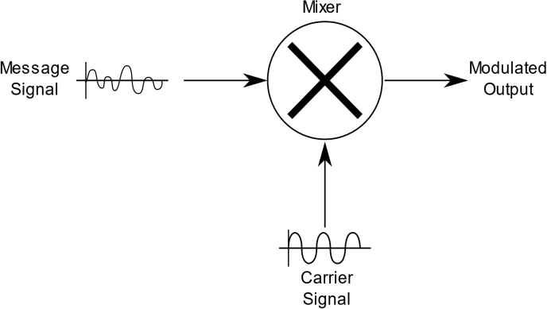
Figure 1
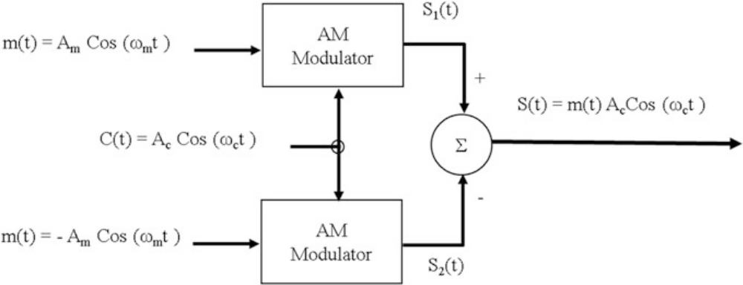
Figure 2
While the power is still off, set the circuit as seen in figure 3 and set the function generator to DC 1 V. Connect the probe of the oscilloscope to the modulated output and switch on the power supply.

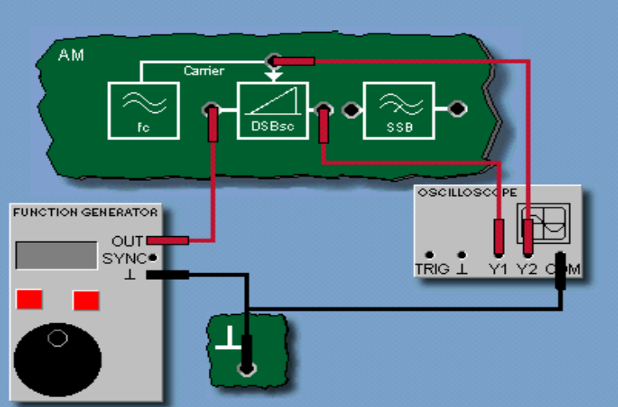
Figure 3
The amplitudes of Y1 and Y2 are used to calculate the modulation coefficients kM as the left input of the modulator is biased with 1 V DC and they are demonstrated in figure 4.
kM = $\frac{Uy_{1}}{Uy_{2}}$

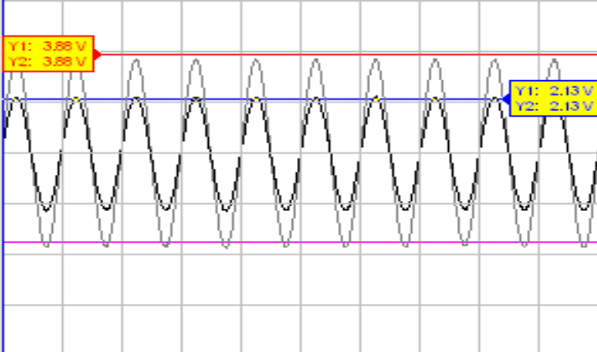
If m (t) sinusoidal with 200 Hz is used, a plot of input and output time and frequency appears as seen in figure 5 and 6.
Figure 4
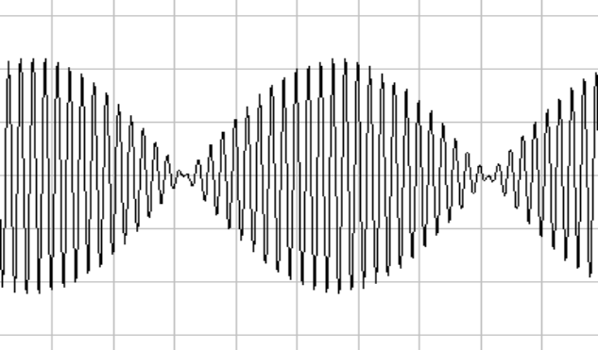
Figure 5
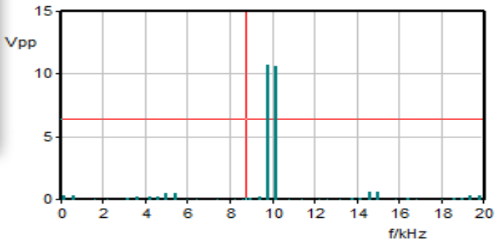
Figure 6

Experiment 2: AM transmitted carrier (full AM)
The equations for amplitude modulation can be demonstrated using trigonometric calculations. Basically an amplitude modulated wave has a frequency carrier and a modulating wave. The frequency carrier is a sine wave at one frequency, which is typically the original portion of the signal spectrum. The modulating wave could be another sine wave with a lower frequency superimposed over the carrier signal wave. The two waves are multiplied with the equation of how the modulation will affect the frequency of the original signal being as follows:
S(t)= Ac (1+ka mt) cos(2πfct)
= Ac cos(2πfct) + Ac 1+ka mt cos(2πfct)

In this experiment, a low frequency signal with a DC component is used with the carrier being generated in the output signal of the multiplier. Figure 7 demonstrates how the amplitude modulation process occurs.
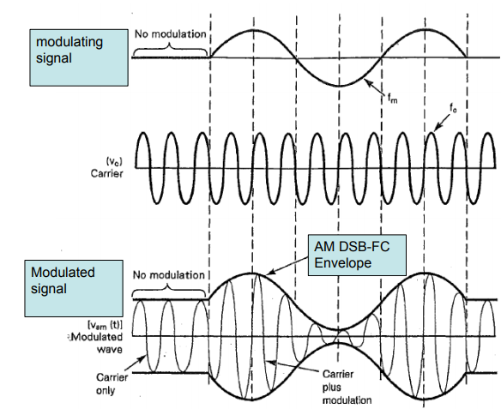
Figure 7
The modulated signals, for example with Mt = 1 kHz, 10Vpp and DC = 0 V would appear as seen in figure 8 and 9.

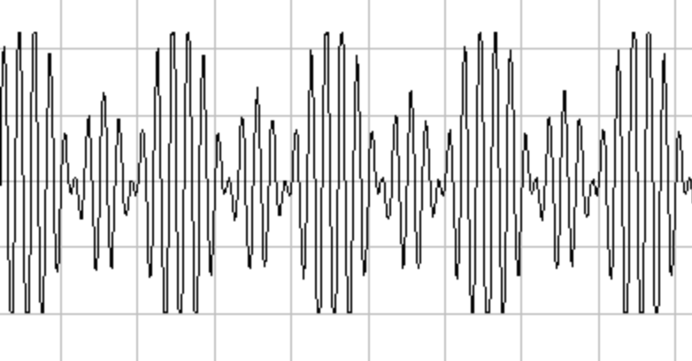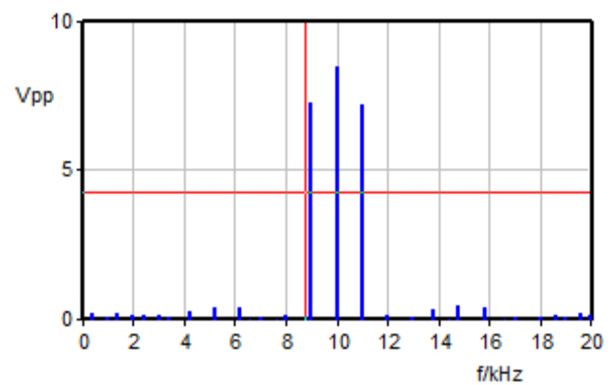
Figure 8 Figure 9

Experiment 3: AM – Demodulation
After modulating communication signals for transmission, it is necessary to retrieve the original signal upon reaching the intended location, a process known as detection or demodulation. AM radio signal is demodulated by correcting it to eliminate one side of the carrier and then filtering it to remove the signal component leaving only the modulating component. This is reminiscent of peak detection with an appropriate time constant. An envelope detector can be used to demodulate high level AM signal waves. A synchronous detector is also used to modulate signals by mixing them with a replica of un-modulated carrier. Figure 10 demonstrates the demodulation process.
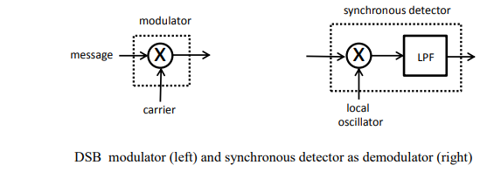
Figure 10
In an experiment using the AM modulator on the TX433 board and the function generator for a DC-free sine wave of frequency f = 1500 Hz and Upp = 2 V, the demodulation process is demonstrated in the figures below. The low-pass filter removes the higher frequency components, so that the carrier signal m(t) can be recovered.
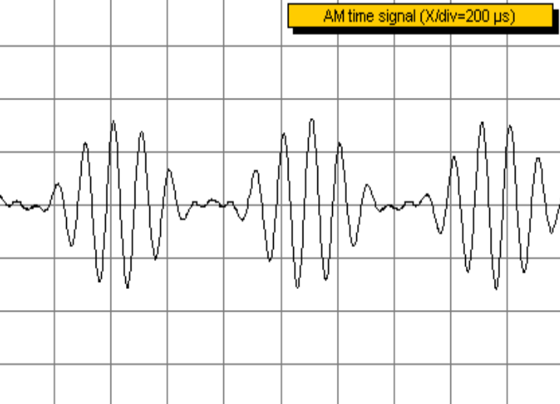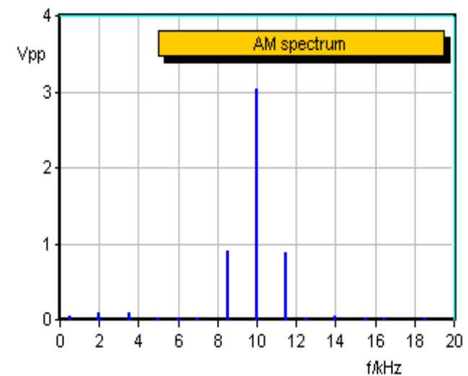
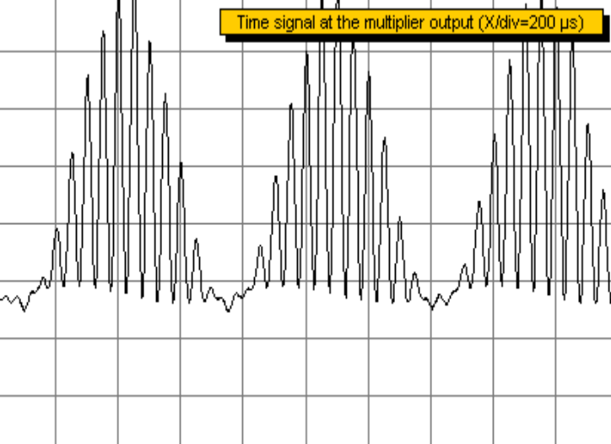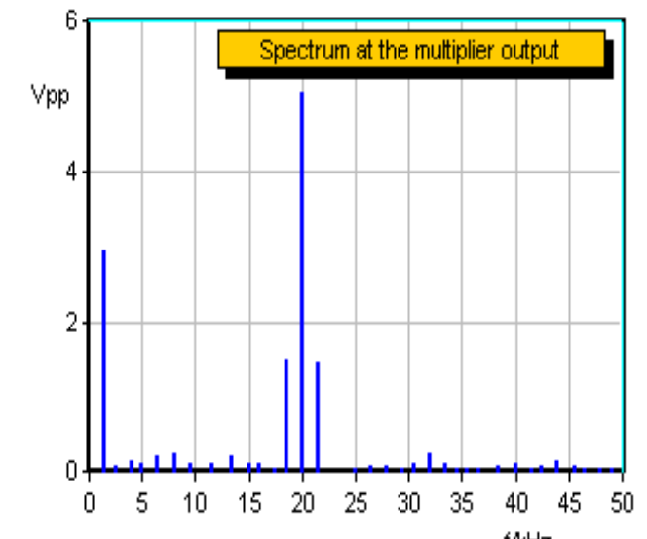
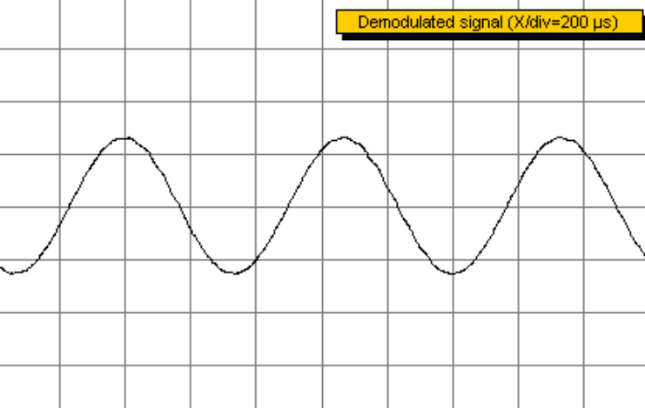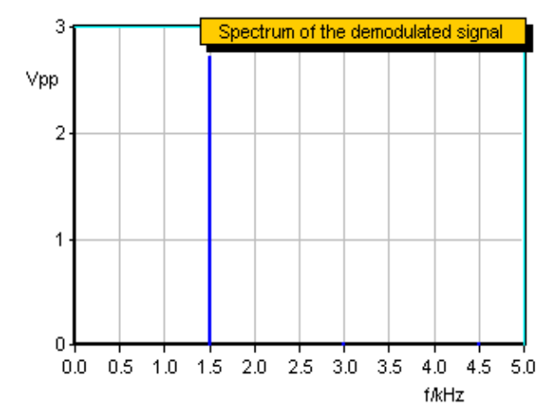

Experiment 4: Frequency modulation (FM)
While altering the amplitude of a communication signal is the most common method of modulation, it not the only way and other techniques such as frequency modulation exist. This technique involves the encoding information in a carrier wave by modifying the wave’s instantaneous frequency. The technology is common in computing, signal processing, radio broadcasting, and telecommunications. Changing the frequency of wave signal gives frequency modulation (FM) and this is common for frequencies of above 30 MHz typically used in VHF FM broadcasting. Although it is not as direct as amplitude modulation, it has some distinctive advantages. It offers almost interference-free reception hence its popularity in VHF audio broadcasts which provide high fidelity audio. The method is more resistant to additive noise that AM>
The components of the method highlighted in figure 11 and 12 as follows:
• m(t) is the input modulating audio signal.
• C(t) is the carrier frequency.
• S(t) is the FM-modulated carrier frequency.
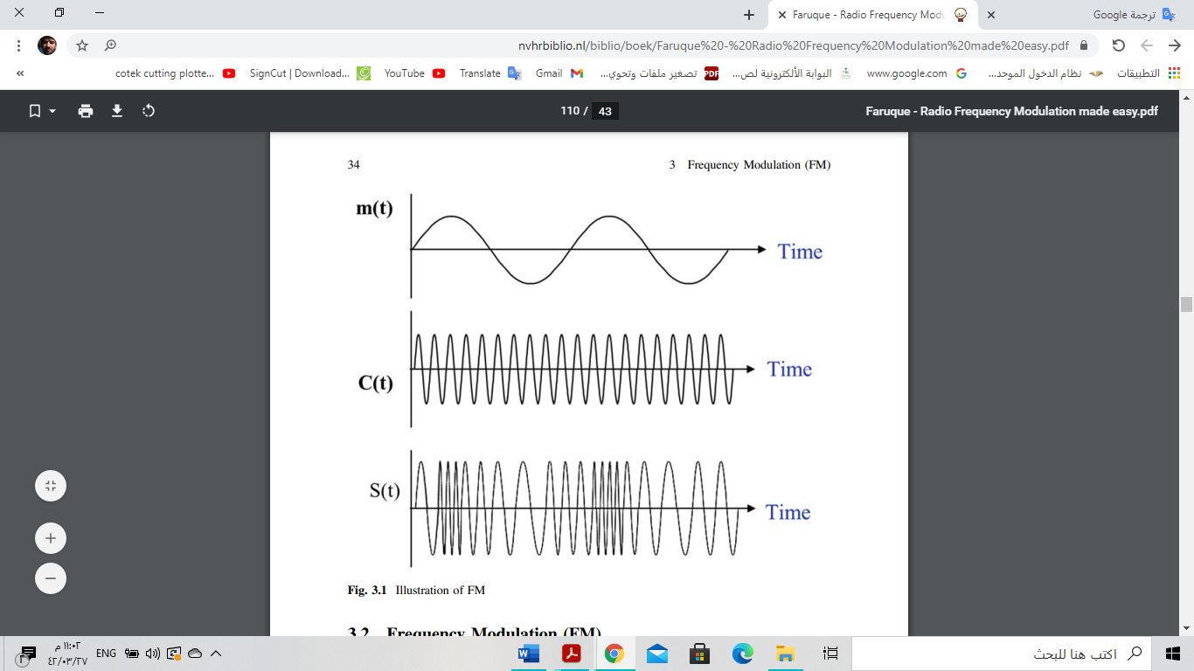
Figure 11

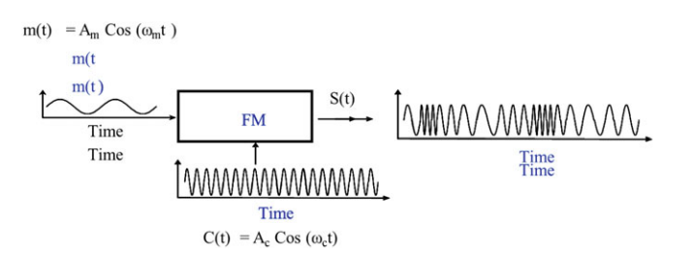
Figure 12
In a sample experiment of FM modulation using a single-tone input modulating signal, m (t) is the input analog signal to be transmitted, C(t) is the carrier frequency before being modulated, and S(t) is the output FM-modulated carrier frequency. The process is represented by the following equation:
F_{i}(t)= Fc(t) + K_{f m}(t)
Where,
• fi = Instantaneous frequency
• fc = Carrier frequency
• K_{f} = Constant.
• m(t) = Am cos (wmt).
The FM-modulated signal is given by:
S(t) = A_{c} Cos(θ_{i})
where Ac is the amplitude of the carrier frequency and θ_{i} is the instantaneous angle. The results of frequency modulation are demonstrated in wave signal of figure 13.

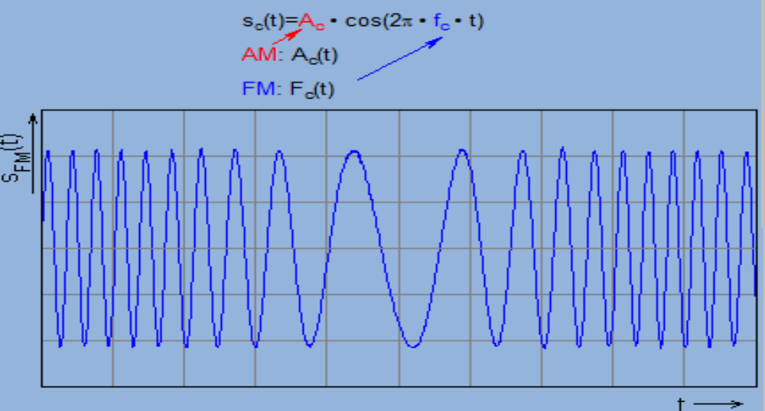
Figure 13

To set up an experiment for frequency modulation, a frequency potentiometer to regulate frequency so that the it is approximately 10kHz at the output. The modulation coefficient k is achieved through the equation Uin = 0 V, which gives the value k = -282.8. For a 20Vpp, 1 kHz, DC = 0 V, with Y1 and fmax being 20 kHz, the set up will be as demonstrated in figure 14 and 15

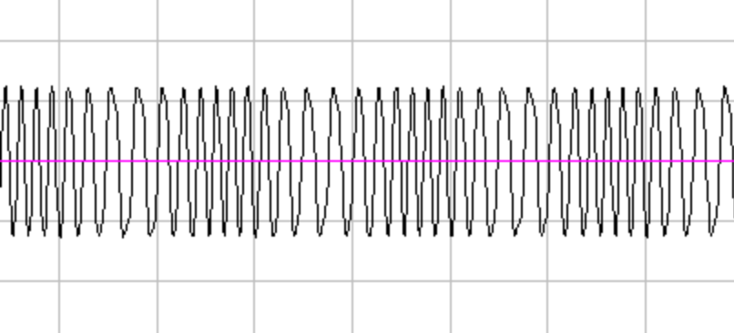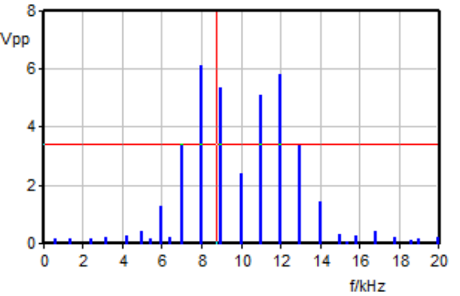
Figure 14 Figure 15

Experiment 5: Amplitude Shift Keying
Amplitude Shift Keying (ASK) is a variant type of amplitude modulation, in which the changes in the carrier amplitude is in discrete units that rely on the input digital signal while the frequency is static. It represents digital data as variations in the amplitude of a carrier wave. in this technique, the modulated signal has a high frequency carrier. The binary signal gives a zero for low input while the high output is the carrier output. The carrier generator continuously transmits a high-frequency-carrier with the binary sequence from the information signal making the unipolar input to be either low or high. The high signal in the ASK modulator closes the switch ensuring that the emerging signal is the carrier wave while low signal input opens the switch making no voltage to present, thereby making the output to be low. Other techniques that apply the same logic include frequency shift-keying and phase shift-keying.
The signal components of ASK and its variants are as follows:
- m(t) is the input modulating digital signal,
- C(t) is the carrier frequency,
- S(t) is the ASK-modulated carrier frequency.
The experiments and their resulting wave graphing could be presented as follows:

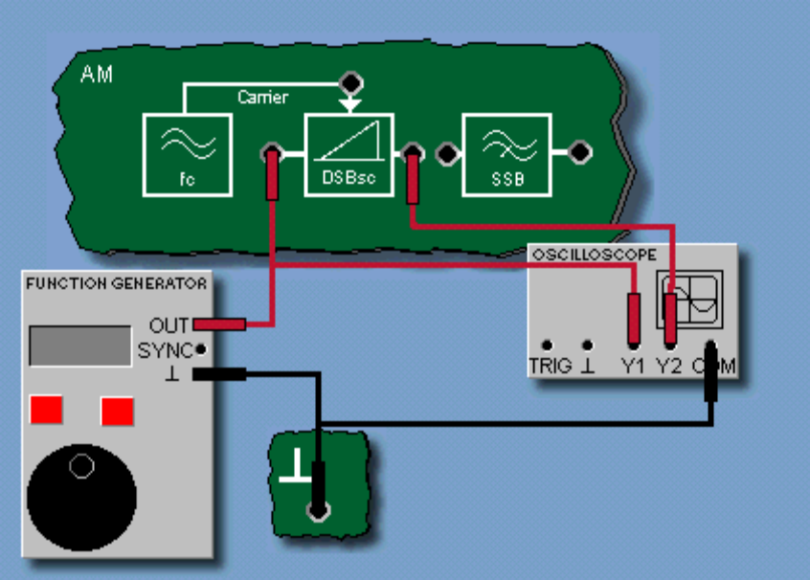
Figure 16

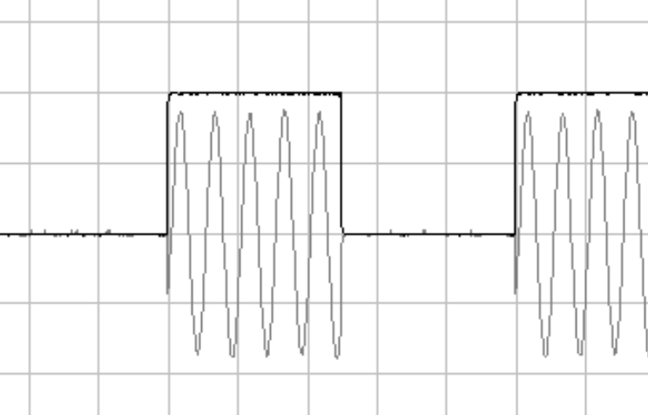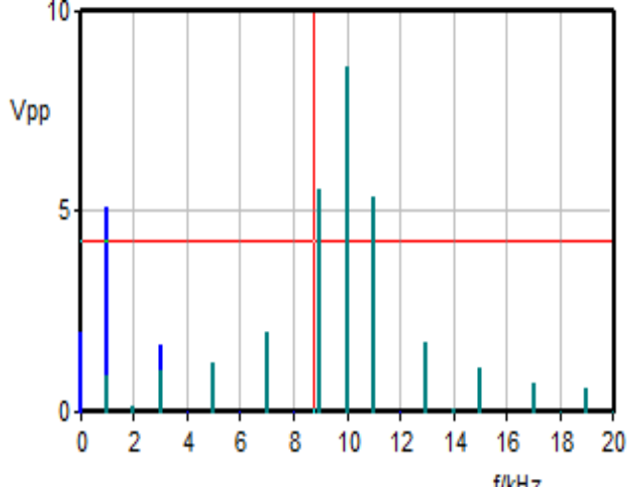
Figure 17 Figure 18

Phase shift-keying:

Figure 19

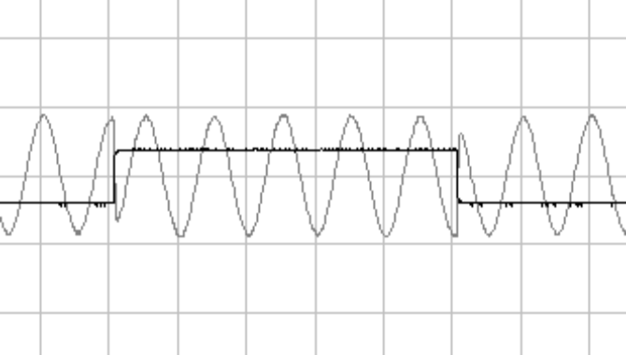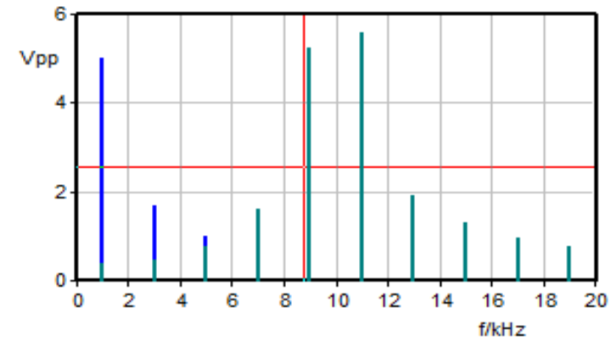
Figure 20 Figure 21
Frequency shift-keying:

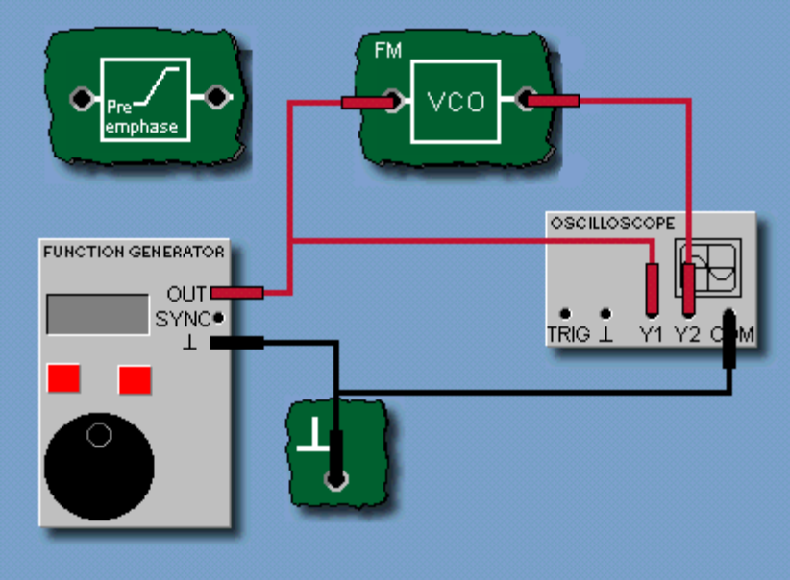
Figure 22

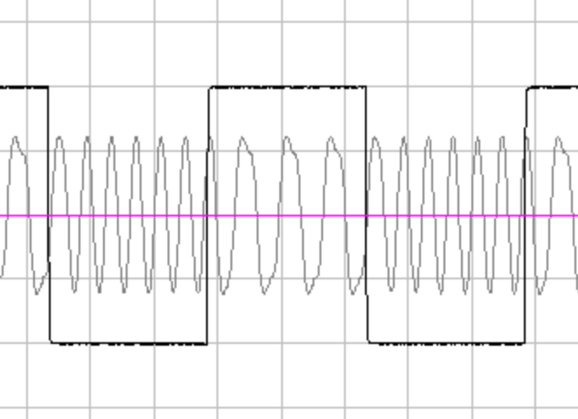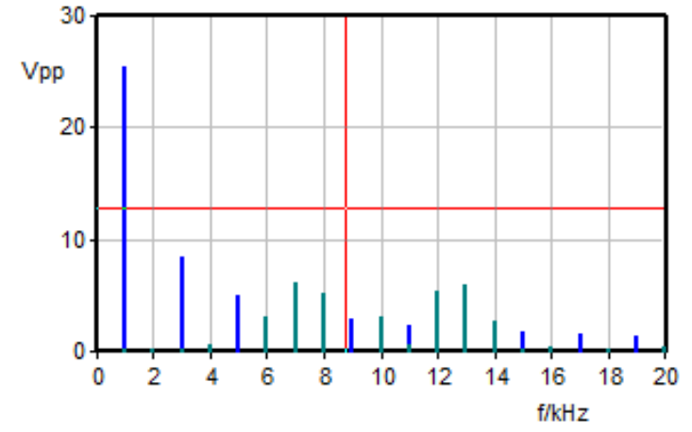
Figure 23 Figure 24

Conclusion
There are various ways to modulate communication signals simplify transmission. Some techniques translate amplitudes to make side bands (DSB and full carrier AM). Others modulate the instantaneous frequency of the original signal to generate a carrier signal. These techniques require demodulation of the signals to revert the information to its original form. A more contemporary approach makes use of amplitude modification in varied discrete forms.

References
Sander, W. B., Meck, R. A., & Mccune Jr, E. W. (2009). U.S. Patent No. 7,515,885. Washington, DC: U.S. Patent and Trademark Office.
Shiikuma, K., & Yamasaki, T. (2004). U.S. Patent No. 6,792,050. Washington, DC: U.S. Patent and Trademark Office.
Supplee, J. M., Whittaker, E. A., & Lenth, W. (1994). Theoretical description of frequency modulation and wavelength modulation spectroscopy. Applied Optics, 33(27), 6294-6302.
Villegas, J. M. L., & Marti, J. S. I. (2005). U.S. Patent No. 6,975,165. Washington, DC: U.S. Patent and Trademark Office.

